Earliest Deadline first

#include <stdio.h>

int main() {
printf("Name:Ojas Manojkumar Ssundatti\n" "USN:1WA24CS196\n" "PRG:Earliest Deadline first (EDF) Algorithm\n");
int n, i;

printf("Enter number of tasks: ");
scanf("%d", &n);

int bt[n], dl[n], p[n];
int rem[n], abs_dl[n];

printf("Enter Burst times:\n");
for (i = 0; i < n; i++) {
scanf("%d", &bt[i]);
rem[i] = 0;
}

printf("Enter Deadlines:\n");
for (i = 0; i < n; i++) {
scanf("%d", &dl[i]);
}

printf("Enter Periods:\n");
for (i = 0; i < n; i++) {
scanf("%d", &p[i]);
}

for (i = 0; i < n; i++) {
abs_dl[i] = dl[i];
}

// Total time
int total_time = p[0];
for (i = 1; i < n; i++) {
if (p[i] > total_time)
total_time = p[i];
}

printf("\nScheduling occurs for %d ms\n\n", total_time);

int prev_idle = 0;

for (int time = 0; time < total_time; time++) {

for (i = 0; i < n; i++) {
if (time % p[i] == 0) {
rem[i] = bt[i];
abs_dl[i] = time + dl[i];
}
}

int selected = -1;
int min_deadline = 9999;

for (i = 0; i < n; i++) {
if (rem[i] > 0) {
if (abs_dl[i] < min_deadline) {
min_deadline = abs_dl[i];
selected = i;
}
}
}

if (selected == -1) {
if (!prev_idle) {
printf("%dms onwards : CPU is idle.\n", time);
prev_idle = 1;
}
} else {
printf("%dms : Task %d is running.\n", time, selected + 1);
rem[selected]--;
prev_idle = 0;
}
}

return 0;
}
OUTPUT
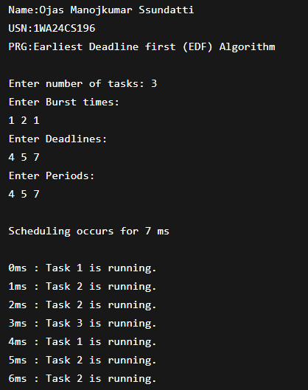

Proportional Share Scheduling
#include <stdio.h>
#include <stdlib.h>
#include <time.h>

typedef struct {
char name[5];
int tickets;
} Process;

int main() {
printf("Name:Ojas Manojkumar Ssundatti\n" "USN:1WA24CS196\n" "PRG:Proportional share scheduling\n");
int n, total_tickets = 0;
float total_T = 0.0;

printf("Enter the number of Processes: ");
scanf("%d", &n);

Process p[n];

srand(time(NULL));

for (int i = 0; i < n; i++) {
printf("\nProcess %d:\n", i + 1);

sprintf(p[i].name, "P%d", i + 1);

printf("Tickets: ");
scanf("%d", &p[i].tickets);

total_tickets += p[i].tickets;
total_T += p[i].tickets;
}

printf("\n--- Proportional Share Scheduling ---\n");

printf("Enter the Time Period for scheduling: ");
int m;
scanf("%d", &m);

for (int i = 0; i < m; i++) {
int winning_ticket = rand() % total_tickets + 1;
int accumulated_tickets = 0;
int winner_index;

for (int j = 0; j < n; j++) {
accumulated_tickets += p[j].tickets;

if (winning_ticket <= accumulated_tickets) {
winner_index = j;
break;
}
}

printf("Tickets picked: %d, Winner: %s\n",
winning_ticket, p[winner_index].name);
}

for (int i = 0; i < n; i++) {
printf("\nThe Process: %s gets %0.2f%% of Processor Time.\n",
p[i].name,
((p[i].tickets / total_T) * 100));
}

return 0;
}

OUTPUT
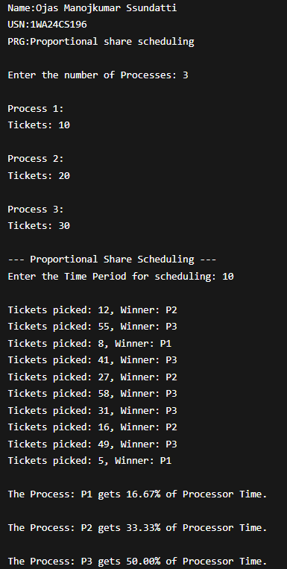

Rate monotonic scheduling

#include <stdio.h>
#include <math.h>

int gcd(int a, int b) {
while (b != 0) {
int t = b;
b = a % b;
a = t;
}
return a;
}

int lcm(int a, int b) {
return (a * b) / gcd(a, b);
}

int main() {
printf("Name:Ojas Manojkumar Ssundatti\n" "USN:1WA24CS196\n" "PRG:Rate monotonic scheduling (RMS) Algorithm\n");
int n, i;

printf("Enter the number of processes:");
scanf("%d", &n);

int bt[n], p[n];

printf("Enter the CPU burst times:\n");
for (i = 0; i < n; i++) {
scanf("%d", &bt[i]);
}

printf("Enter the time periods:\n");
for (i = 0; i < n; i++) {
scanf("%d", &p[i]);
}

int hyper = p[0];
for (i = 1; i < n; i++) {
hyper = lcm(hyper, p[i]);
}

printf("LCM=%d\n\n", hyper);

printf("Rate Monotone Scheduling:\n");
printf("PID\tBurst\tPeriod\n");
for (i = 0; i < n; i++) {
printf("%d\t%d\t%d\n", i + 1, bt[i], p[i]);
}

float U = 0;
for (i = 0; i < n; i++) {
U += (float)bt[i] / p[i];
}

float bound = n * (pow(2, (float)1/n) - 1);

printf("\n%f <= %f => %s\n",
U, bound, (U <= bound) ? "true" : "false");

printf("Scheduling occurs for %d ms\n", hyper);

int rem[n];
for (i = 0; i < n; i++)
rem[i] = 0;

printf("\n");

int prev = -2;

for (int time = 0; time < hyper; time++) {

for (i = 0; i < n; i++) {
if (time % p[i] == 0) {
rem[i] = bt[i];
}
}

int selected = -1;

for (i = 0; i < n; i++) {
if (rem[i] > 0) {
if (selected == -1 || p[i] < p[selected]) {
selected = i;
}
}
}

if (selected != prev) {
if (selected == -1)
printf("%dms onwards: CPU is idle\n", time);
else
printf("%dms onwards: Process %d running\n", time, selected + 1);
}

if (selected != -1) {
rem[selected]--;
}

prev = selected;
}

return 0;
}
OUTPUT
